Microsoft SQL server

Data type – support for validation

according to the SQL standard

FOR XML

OPENXML

XML methods

Query(Xquery)

Value

Exist

Modify(DML)

nodes

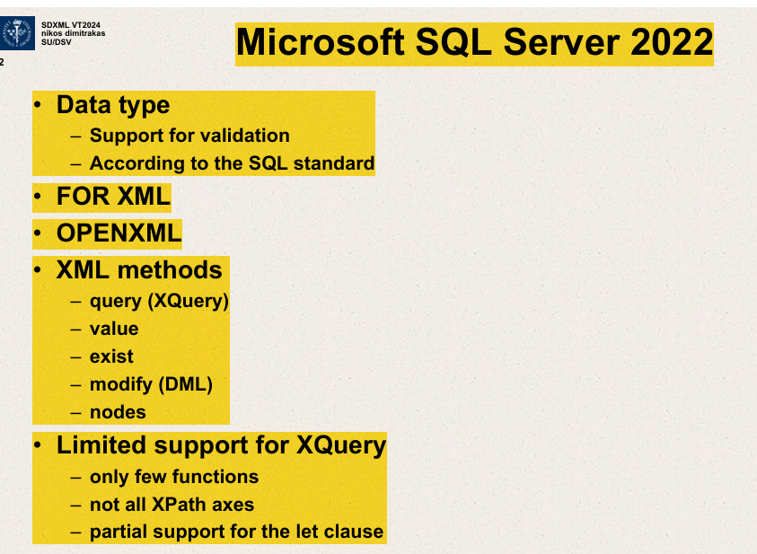

This slide is about features and functionalities related to XML handling in Microsoft SQL Server 2022. Here’s a breakdown of the slide's content:

Data types in SQL server 2022 support validation mechanisms to ensure data conforms to specific rules or standards.

1. **Data type**
   * **Support for validation:** Indicates that the data types in SQL Server 2022 support validation mechanisms to ensure data conforms to specified rules or standards.
   * **According to the SQL standard:** The data types adhere to SQL standards, likely referring to ANSI or ISO SQL standards for compatibility and interoperability.
2. **FOR XML**
   * This might refer to SQL Server's FOR XML clause, which is used to return query results as XML documents.

**SQL server’s FOR XML clause is used to return query results as XML documents.**

1. **OPENXML**
   * **A method in SQL Server that provides a way to access XML data within SQL and handle it as SQL rows.**

**Essentially, it allows you to query data in an XML document as if it were normal relational table data.**

1. **XML methods**
   * **Lists various methods used to query or modify XML data within SQL Server:**
     + **query (XQuery):** Uses XQuery, a language designed to query XML data.
     + **value:** Extracts values from XML documents.
     + **exist:** Tests for the existence of XML nodes.
     + **modify (DML):** Allows modification of XML data using Data Manipulation Language (DML) statements.
     + **nodes:** A method to shred XML data into relational format.
2. **Limited support for XQuery**
   * Indicates that while SQL Server supports XQuery, there are limitations:

While SQL server supports Xquery ,there are limitations.

* + - **Only few functions:** Not all XQuery functions are supported.
    - **Not all XPath axes:** Indicates partial support for different paths that can be used in queries to navigate XML documents.
    - **Partial support for the let clause:** The **let** clause in XQuery, which is used for variable assignment, has limited support.

Overall, this slide is summarizing the capabilities and some limitations of handling XML data within Microsoft SQL Server 2022, focusing on how XML can be queried, manipulated, and integrated with SQL data operations.

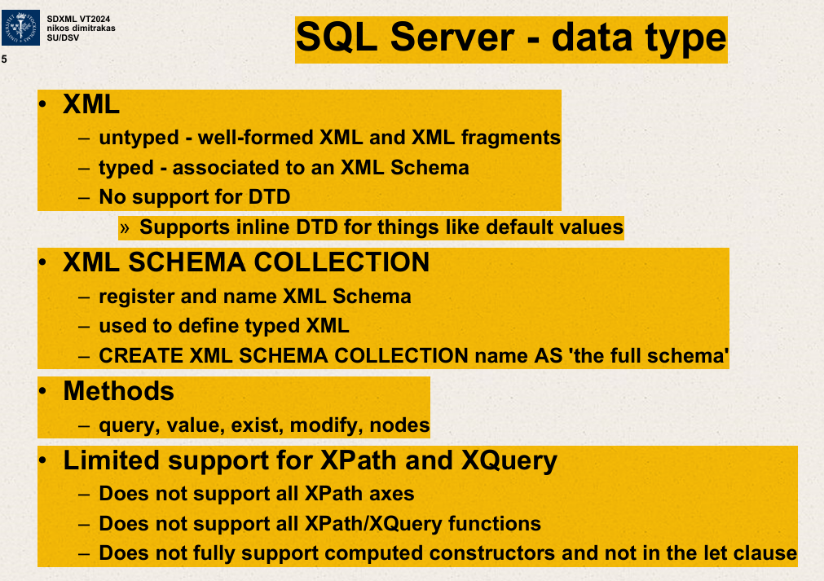

**This slide focuses on XML data types within SQL Server and specifically explores handling and constraints related to XML data.**

**All XML data types within SQL Server**

1. **XML Data Type:**
   * **Untyped: Refers to XML data that is well-formed but not associated with any XML schema. This allows flexibility in storing arbitrary well-formed XML fragments.**
   * **Typed: Refers to XML data that is associated with an XML Schema. This helps in validating XML data against a predefined schema to ensure data integrity and structure.**
   * **No support for DTD: Document Type Definitions (DTD) are not supported by SQL Server for XML data types. DTDs are older mechanisms for defining the structure of XML documents.**
   * **Supports inline DTD:** Despite the general lack of support for DTD, SQL Server allows inline DTDs for specific purposes like setting default values within XML documents.
2. **XML Schema Collection:**
   * **Allows users to register and name XML Schemas within SQL Server.**
   * **It is used to define and enforce structure on typed XML data.**
   * **CREATE XML SCHEMA COLLECTION: A SQL command used to create and register an XML Schema in the server, which can be associated with typed XML data.**

**CREATE XML SCHEMA COLLECTION – command used to create and register an XML schema in the server.**

**Typed XML – associated with an XML schema.**

1. **Methods:**
   * **These are methods for querying and manipulating XML data within SQL Server.**
     + **query: Perform queries on XML data using XQuery.**
     + **value: Retrieve values from XML elements or attributes.**
     + **exist: Check the existence of XML nodes.**
     + **modify: Make changes to XML data.**
     + **nodes: Shred XML data into relational format,**

**i.e., converting it into rowsets that can be used like regular table data.**

1. **Limited Support for XPath and XQuery:**
   * **Does not support all XPath axes:** XPath is a language used to navigate through elements and attributes in an XML document. SQL Server does not support all navigational paths defined in XPath.
   * **Does not support all XPath/XQuery functions:** There are limitations in the functions available for querying XML data.
   * **Does not fully support computed constructors and not in the let clause:** Indicates limitations in using computed constructors in XQuery and restrictions in using the **let** clause for assigning values within queries.

This slide essentially outlines the capabilities and limitations of SQL Server when working with XML data, emphasizing how XML is integrated into SQL Server, how it is structured and queried, and highlighting some specific restrictions in its XML processing functionalities.

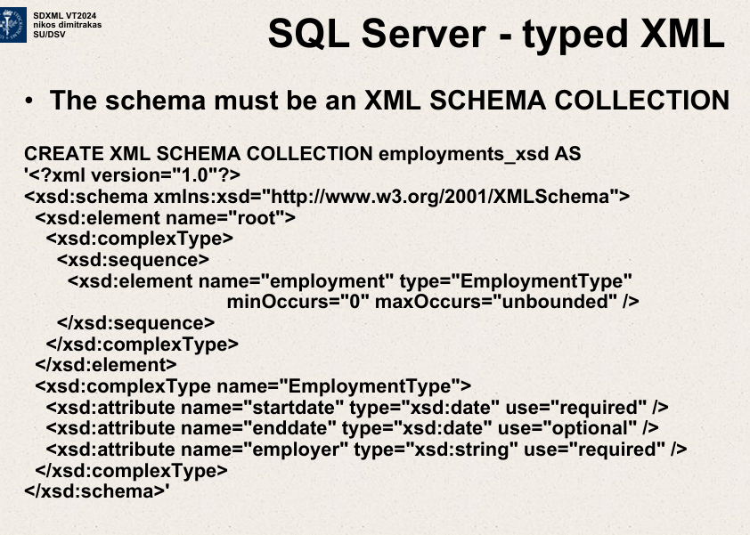

This slide outlines how to define a typed XML schema in SQL Server using the XML Schema Definition (XSD) language.

Here's an explanation of the key components displayed on the slide.

1. **Purpose: The slide demonstrates creating a typed XML schema collection in SQL Server. Typed XML allows SQL Server to validate XML documents against the schema to ensure they meet specific structure and type requirements.**
2. **WWCREATE XML SCHEMA COLLECTION Syntax**:
   * **CREATE XML SCHEMA COLLECTION employments_xsd AS: This SQL command is used to create an XML schema collection named employments_xsd. This collection will contain one or more XML schemas.**
3. **XML Schema Example**:
   * **<?xml version="1.0"?>** declares the XML version.
   * **<xsd:schema xmlns:xsd="http://www.w3.org/2001/XMLSchema">** begins the schema definition, specifying that schema elements will be defined using the XML Schema namespace.
   * **<xsd:element name="root">** defines the root element of XML documents that conform to this schema.
   * Inside the root element:
     + **<xsd:complexType>** starts the definition of a complex type, meaning this XML element will contain other elements or attributes.
     + **<xsd:sequence>** indicates that child elements must appear in a sequence.
     + **<xsd:element name="employment" type="EmploymentType">** defines an element named "employment" that must conform to a type called **EmploymentType**. This type isn't defined in the provided snippet but would be defined elsewhere in the schema.
       - **minOccurs="0" maxOccurs="unbounded"** specifies that the "employment" element can appear zero or more times, making it optional and repeatable.
   * **<xsd:complexType name="EmploymentType">** likely defines the **EmploymentType**, which includes:
     + Attributes like **startdate** and **employer**:
       - **<xsd:attribute name="startdate" type="xsd:date" use="required"/>** defines a required date attribute named "startdate".
       - **<xsd:attribute name="enddate" type="xsd:date" use="optional"/>** defines an optional date attribute named "enddate".
       - **<xsd:attribute name="employer" type="xsd:string" use="required"/>** defines a required string attribute named "employer".
4. **Significance**:
   * This schema setup in SQL Server allows for the enforcement of rules and structures on XML data, which aids in data integrity and validation.
   * The slide is an example of how complex XML structures are defined and used within a database system to handle richly structured data efficiently.

This type of schema definition is crucial for applications where XML data needs to be strictly validated and integrated with SQL databases, ensuring that the data adheres to specified formats and structures.

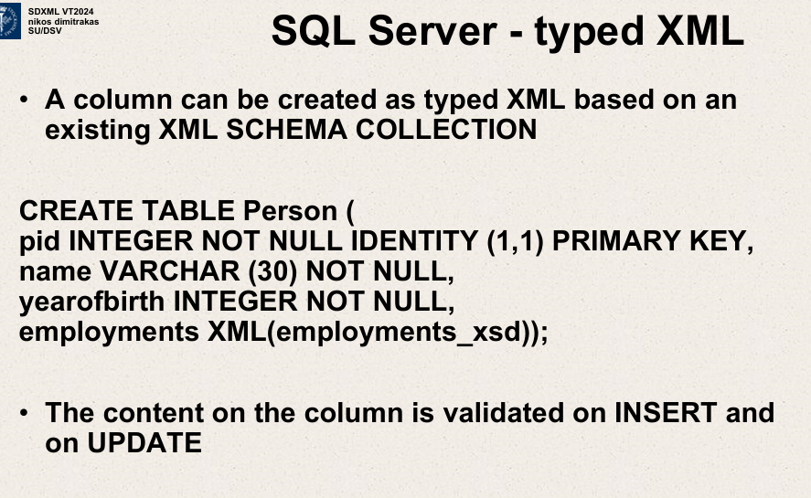

A column can be created as typed XML based on an existing XML schema collection.

CREATE TABLE Person (

pid INTEGER NOT NULL IDENTITY (1,1) PRIMARY KEY,

name VARCHAR(30) NOT NULL,

yearofbirth INTEGER NOT NULL,

employments XML(employments_xsd));

Content on the column is validated on INSERT and on UPDATE.

pid INTEGER NOT NULL IDENTITY (1,1) PRIMARY KEY

pid, name, yearofbirth ,employments XML

SQL Server and SQL/XML

No support for the publishing functions

* For XML clause in the select statement instead.

No support for XMLQUERY ,XMLTABLE ,XMLEXISTS

-XML methods instead.(partially also OPENXML)

No support for XMLVALIDATE

-validation automatic for typed XML

No support for XMLCAST

-general function CAST is enough (and CONVERT)

**SQL Server – OPENXML**

**Converts XML data to relational data**

**Requires the use of procedures.**

**Can generate one row per node**

* **Default, the result is a so called “edge table.”**

**Can generate one column per specified expression**

* **With the KEYWORD WITH**

**Suitable for batch shredding of XML files**

SQL server – FOR XML

Extra clause in SELECT statements.

Converts result to XML according to different modes.

RAW  
AUTO  
EXPLICIT   
PATH  
Result is always an XML value.

**-Either a fragment or well formed XML with keyword ROOT.**

**-Either serialized or of XML data type with keyword TYPE.**

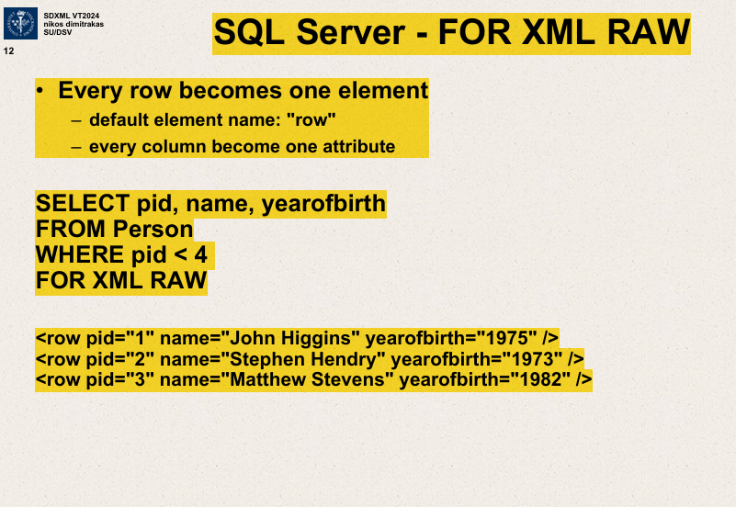

SQL SERVER – FOR XML RAW  
Every row becomes one element

-default element name:”row”

-every column becomes one attribute

SELECT pid,name,yearofbirth

FROM Person

WHERE pid<4

FOR XML RAW

<row pid=”1” name=”John Higgins” yearofbirth=”1975”/>

<row pid=”2” name=”Stephen Hendry” yearofbirth="1973”/>

Shredding – breaking up XML into its nodes and data.

Commonly done in order to put data into a relational DB.

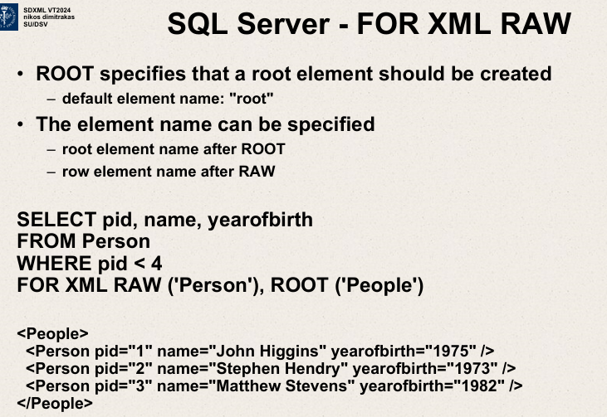

SELECT pid,name,yearofbirth

FROM Person

WHERE pid<4

FOR XML RAW (‘Person’),ROOT(‘People’)

<People>

<Person pid=”1” name=”John Higgins” yearofbirth=”1975”/>

<Person pid=”2” name=”Stephen Hendry” yearofbirth=”1973”/>

<Person pid=”3” name=”Matthew Stevens” yearofbirth=”1982”>

</People>

ELEMENTS specifies that elements should be created instead of attributes (for each column)

Element names(or attribute names) are based on SELECT clause.

pid->PersonID

name->FullName

yearofbirth->Yob

SELECT pid AS PersonID ,name AS FullName,

yearofbirth AS Yob

FROM Person

WHERE pid=2

FOR XML RAW(‘Person’),ROOT(‘People’),ELEMENTS  
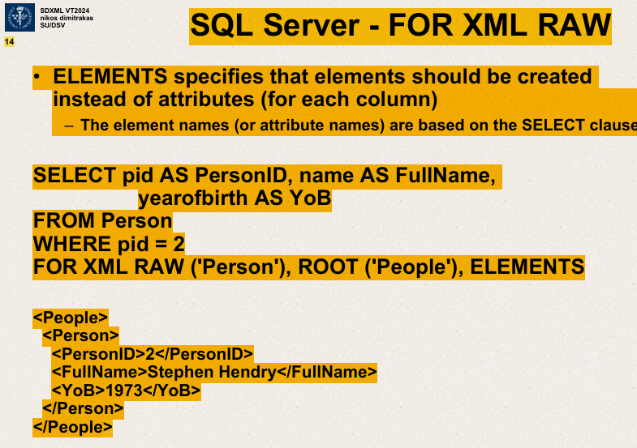

<People>

<Person>

<PersonID> 2</PersonID>

<FullName> Stephen Hendry </FullName>

<YoB> 1973 </YoB>

</Person>

</People>

FOR XML AUTO  
Elements are created automatically

SELECT pid,name,yearofbirth

FROM Person

WHERE pid<4

FOR XML AUTO

Root element name after ROOT

Row element name after RAW

SELECT pid, name, yearofbirth

FROM Person

WHERE pid<4

FOR XML RAW(‘Person’),ROOT(‘People’)

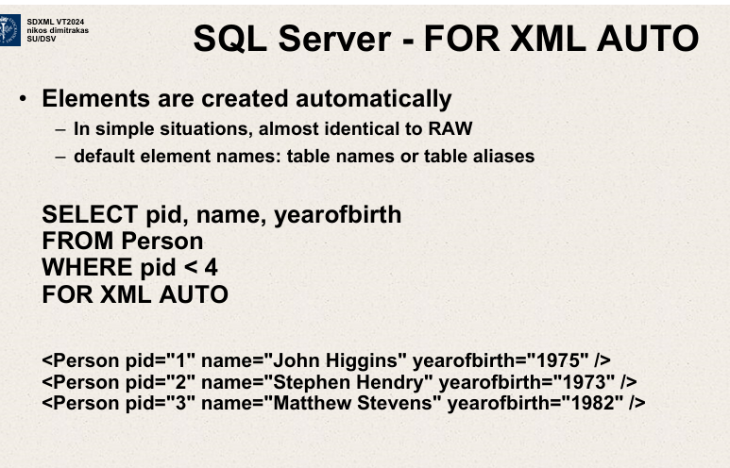

SELECT pid, name, yearofbirth

FROM Person

WHERE pid<4

FOR XML AUTO

This slide demonstrates how to create a database table in SQL Server that includes a column defined with typed XML data. Here's a detailed explanation:

1. **Typed XML Column Based on an XML Schema Collection**:
   * The slide states that a column in SQL Server can be defined as typed XML, which means the XML data stored in this column must conform to a specific XML Schema Collection previously defined. This ensures that the data adheres to a predefined structure and validation rules.
2. **SQL Table Creation Syntax**:
   * **CREATE TABLE Person (...)**: This command is used to create a new table named **Person** in the database.
     + **pid INTEGER NOT NULL IDENTITY (1,1) PRIMARY KEY**: Defines a column named **pid** as an integer, which cannot be null. It automatically increments starting from 1 and acts as a primary key.
     + **name VARCHAR (30) NOT NULL**: Defines a column named **name** with a character limit of 30, which cannot be null.
     + **yearofbirth INTEGER NOT NULL**: Defines a column named **yearofbirth** as an integer that also cannot be null.
     + **employments XML(employments_xsd)**: Defines a column named **employments** that will store XML data. This data must conform to the **employments_xsd** XML Schema Collection, thus making it a typed XML column.
3. **Data Validation**:
   * The slide notes that content in the **employments** XML column is validated on **INSERT** and **UPDATE** operations. This means whenever data is inserted into or updated in the **employments** column, SQL Server checks if the data conforms to the **employments_xsd** schema. If the data does not meet the schema requirements, SQL Server will reject the operation and raise an error.

This setup is beneficial for maintaining data integrity and ensuring that the XML data stored in the database complies with the specific format and rules defined by the XML schema. It is particularly useful in applications where the structure and correctness of data are critical, such as in configurations, user settings, or any complex data relationships represented in XML format.

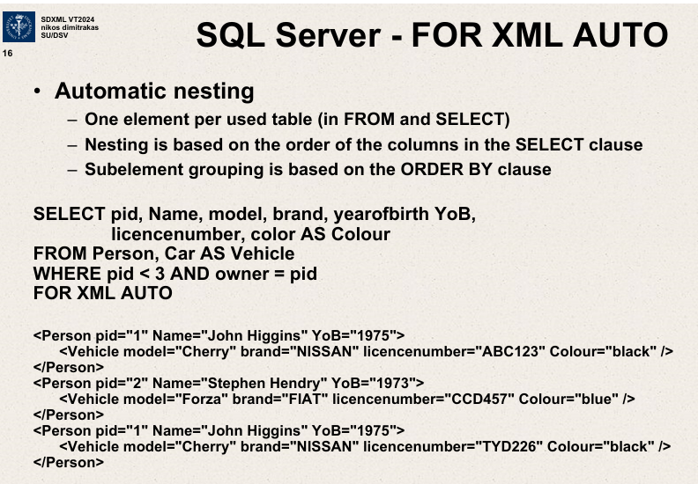

Automatic nesting

One element per used table (in FROM and SELECT)

Nesting based on order of columns in SELECT clause.

Subelement grouping based on ORDER BY clause.

SELECT pid, Name , model, brand, yearofbirth YoB,

licencenumber, color AS Colour

FROM Person,Car AS Vehicle

WHERE pid<3 and owner=pid

FOR XML AUTO

<Person pid=”1” Name=”John Higgins” YoB=”1975”>

<Vehicle model=”Cherry” brand=”NISSAN” licensenumber=”ABC123” Colour=”black”/>

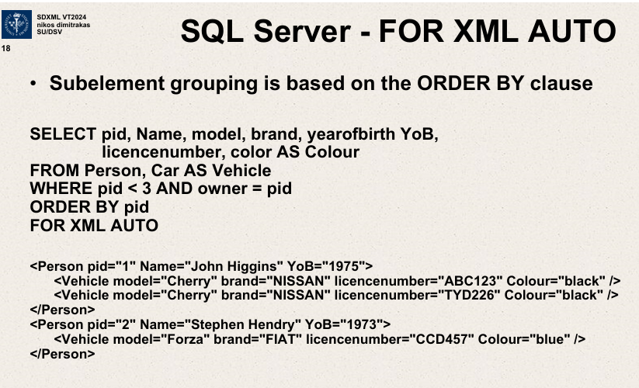

Subelement grouping based on ORDER BY clause.

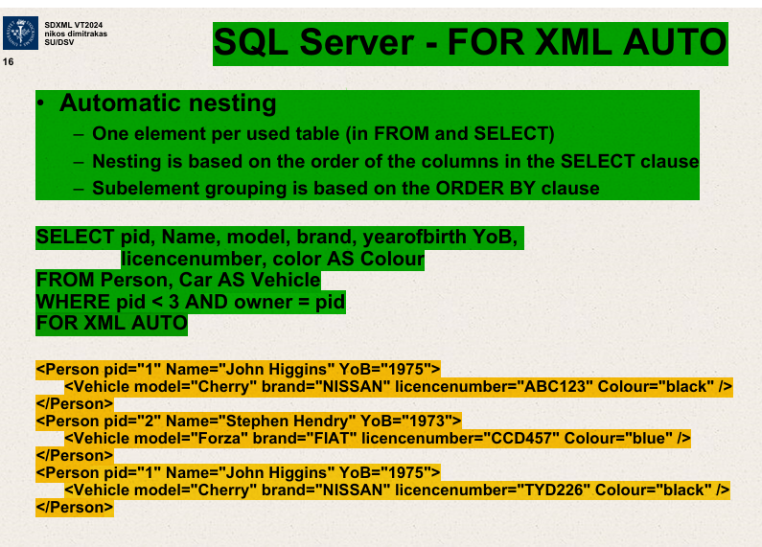

FOR XML AUTO - Automatic nesting

One element per used table (in FROM and SELECT)

Nesting based on order of columns in SELECT clause

Sub-element grouping based on ORDER BY clause

SELECT pid, Name, model, brand, yearofbirth YoB, licencenumber , color AS Colour

FROM Person, Car AS Vehicle

WHERE pid<3 and owner=pid

FOR XML AUTO

<Person pid=”1” Name=”John Higgins” YoB=”1975”>

<Vehicle model=”Cherry” brand=”NISSAN” licensenumber=”ABC123” Colour=”black”/>

</Person>

<Person pid=”1” Name=”John Higgins” YoB=”1975”>

<Vehicle model=”Cherry” brand=”NISSAN” licensenumber=”ABC123” Colour=”black”/>

</Person>

<Person pid=”2” Name=”Stephen Hendry” YoB=”1973”>

<Vehicle model=”Forza” brand=”FIAT” licensenumber=”CCD457” Colour=”blue”/> </Person>

SQL Server – FOR XML AUTO

Elements are created automatically.

In simple situations ,identical to RAW

default element names;table names or table aliases.

<Person pid=”1” Name=”John Higgins” YoB=”1975”>

<Vehicle model=”Cherry” brand=”NISSAN” licensenumber=”ABC123” Colour=”black”/>

</Person>

<Person pid=”2” Name=”Stephen Hendry” Yob=”1973”>

<Vehicle model=”Forza” brand=”FIAT” licensenumber=”CCD457” Colour=”blue” />

</Person>

<Person pid=”1” Name=”John Higgins” YoB=”1975”>

<Vehicle model=”Cherry” brand=”NISSAN” licensenumber=”TYD226” Colour=”black”/>

</Person>

The image you uploaded pertains to SQL Server's "FOR XML AUTO" mode, which is a method for automatically formatting the results of a SQL query as XML. Here’s a breakdown of the concepts and SQL query shown in your image:

**Automatic Nesting**

* **One element per used table (FROM and SELECT):** Each table used in the FROM and SELECT clauses of the SQL query is represented as a separate XML element.
* **Nesting is based on the order of the columns in the SELECT clause:** The structure or nesting of the XML elements is determined by how columns are ordered in the SELECT clause.
* **Subelement grouping is based on the ORDER BY clause:** If an ORDER BY clause is used, it can influence the grouping of the sub-elements within the generated XML.

**Example SQL Query**

The SQL query provided in your image is designed to fetch data from the tables "Person" and "Car" (aliased as "Vehicle") and output the result in an XML format:

sql

Copy code

SELECT pid, Name, model, brand, yearofbirth YoB, licencenumber, color AS Colour

FROM Person, Car AS Vehicle

WHERE pid < 3 AND owner = pid

FOR XML AUTO

**Key Points in the Query:**

* **SELECT Clause:** Lists the columns to be included from the "Person" and "Car" tables. It also includes renaming some columns using aliases (like yearofbirth as YoB and color as Colour).
* **FROM Clause:** Indicates the data sources; "Person" and "Car" (with an alias of "Vehicle").
* **WHERE Clause:** Filters records where the 'pid' (person id) is less than 3 and the 'owner' column in the "Car" table matches the 'pid'.
* **FOR XML AUTO:** Directs SQL Server to return the results formatted as XML. In this mode, SQL Server automatically creates nested XML based on the tables referenced and the relationships between them (in this case, implied by the query).

**XML Output**

The XML output shows nested elements where each <Person> element contains nested <Vehicle> elements. Each person can have multiple vehicles listed under them, showing attributes like model, brand, license number, and color. The nesting directly corresponds to how tables are joined and the relationships defined in the SQL query.

This functionality is particularly useful for applications that require XML output, such as web services or data interchange between systems. It simplifies converting table data directly into a structured XML format without needing additional processing or transformation outside of SQL Server.

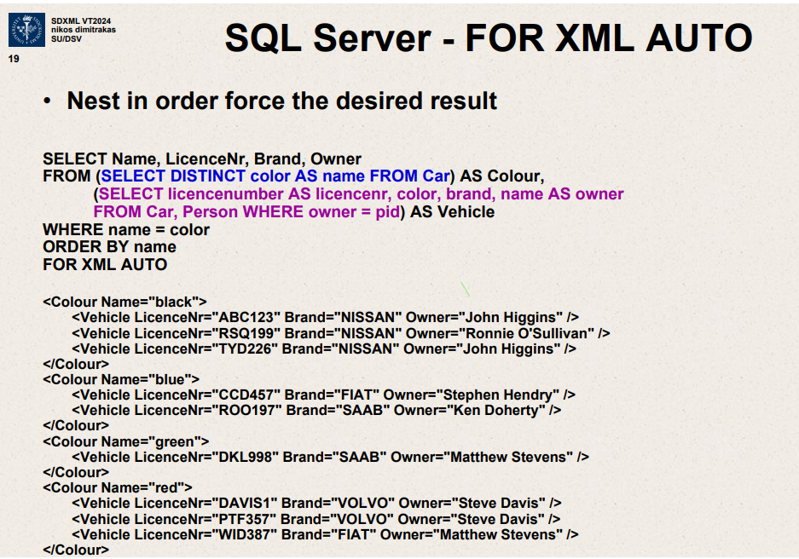

Nest in order force the desired result.  
SELECT Name, LicenceNr, Brand, Owner

FROM (SELECT DISTINCT color AS name FROM Car) AS Colour,

(SELECT licensenumber AS licencenr,color,brand,name AS owner

FROM Car, Person WHERE owner=pid) AS Vehicle

WHERE name=color

ORDER BY name

FOR XML AUTO

<Colour name=”black”>

<Vehicle LicenceNr Brand Owner />

</Colour>

This SQL code is an example of using SQL Server's FOR XML AUTO feature to format the results of a query as XML.

Here's a breakdown of the SQL code and what each part does:

1. **Nested Subquery Structure**: The query has nested subqueries to structure the data in a specific way before it is formatted into XML.

The innermost query selects distinct colors, license numbers, brand, and owner details from the Car table joined with the Person table.

It aliases these to different names (e.g., licencenumber is aliased to licencenr, name from the Person table to owner).

1. **Middle Subquery**: This subquery renames the color fetched from the Car table as name. This is important because in the XML output, name will be used as an attribute for the <Colour> tag.
2. **Outer Query**: The outer query selects these columns and orders them by name (which is actually the color due to the aliasing in the middle subquery). This order dictates how the XML will be structured - grouping cars by their color.
3. **FOR XML AUTO**: This statement is used to automatically generate an XML output based on the column names and their hierarchical arrangement in the SELECT statement. The AUTO mode decides the nesting of XML elements based on the order and grouping of columns in the SELECT statement.
   * **XML Output Structure**: The XML is structured with a <Colour> element for each color. Within each <Colour> element, there are multiple <Vehicle> elements. Each <Vehicle> element has attributes such as LicenceNr, Brand, and Owner. The naming and structure are directly derived from the alias names and structure of the SQL query.

In summary, this SQL query is structured to convert tabular data about cars and their owners into a nested XML format, grouped by car color with details about each vehicle as attributes of <Vehicle> tags nested under their respective <Colour>. This makes it easier to handle in applications that prefer XML for data exchange.

SELECT Name,LicenceNr,Brand,Owner

FROM ( SELECT DISTINCT color AS name FROM Car) AS Colour,

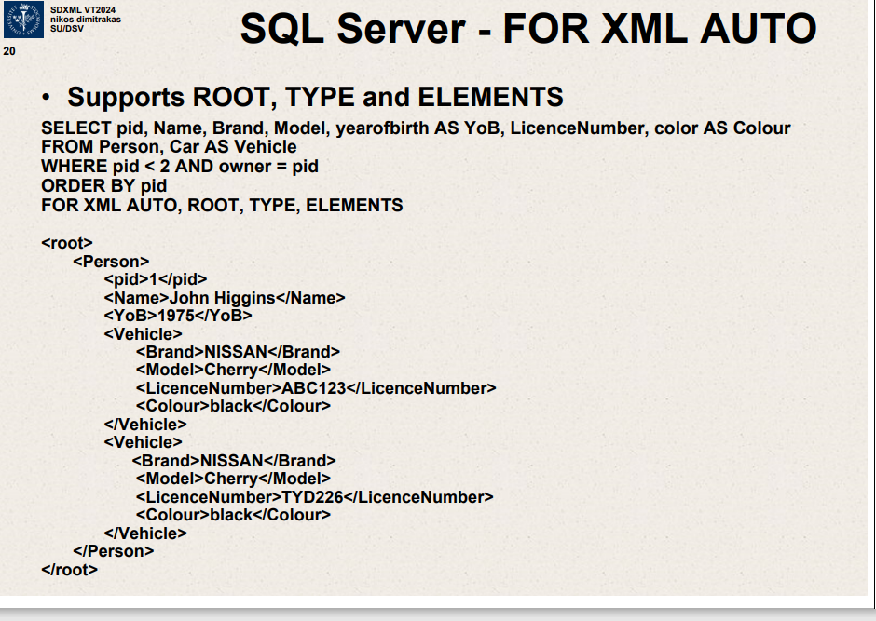

SELECT pid,Name,Brand,Model,yearofbirth AS YoB,LicenceNumber,color AS Colour

FROM Person, Car AS Vehicle

WHERE pid<2 AND owner=pid

ORDER BY pid

FOR XML AUTO ,ROOT ,TYPE ,ELEMENTS

SQL Server – FOR XML AUTO

Supports ROOT, TYPE and ELEMENTS

<root>

<Person>

<pid> 1 </pid>

<Name> John Higgins </Name>

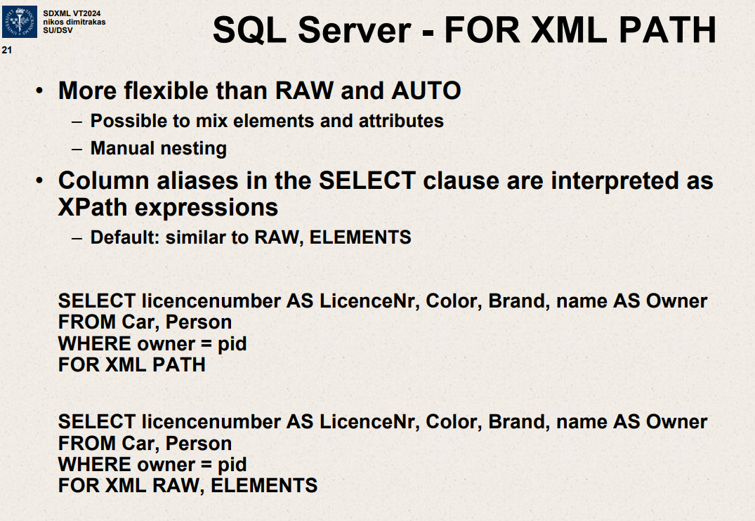

SQL Server – FOR XML PATH

More flexible than RAW and AUTO

Possible to mix elements and attributes

Manual nesting

Column aliases in the SELECT clause are interpreted as Xpath expressions

Default – similar to RAW,ELEMENTS

SELECT licensenumber AS LicenceNr,Color,Brand,name AS Owner

FROM Car,Person

WHERE owner=pid

FOR XML PATH

SELECT licensenumber AS LicenceNr,Color,Brand,name AS Owner

FROM Car,Person

WHERE owner=pid

FOR XML RAW, ELEMENTS

SELECT licensenumber AS LicenceNr ,Color ,Brand ,name AS Owner

FROM Car,Person

WHERE owner=pid

FOR XML PATH

The slide you uploaded provides an overview of SQL Server's FOR XML PATH clause, which is used to generate XML output from SQL queries. Here's a breakdown of the key points mentioned on the slide:

**Flexibility Over RAW and AUTO Modes**

* The FOR XML PATH mode in SQL Server is more flexible compared to RAW and AUTO modes.
* It allows you to manually specify how elements and attributes are mixed and nested in the resulting XML.
* This customization is achieved by providing more control over the structure of the XML output.

**Column Aliases as XPath Expressions**

* In the SELECT clause, column aliases can be used as XPath expressions. This helps in defining the structure and hierarchy of the resulting XML document.
* By default, the behavior is similar to RAW and ELEMENTS modes, which structure each row of the query result as an XML element with child elements for each column.

**Examples**

1. **First Query Example:**

SELECT licencenumber AS LicenceNr, Color, Brand, name AS Owner

FROM Car, Person

WHERE owner = pid

FOR XML PATH

* + This query will output XML where each row returned by the query is represented as a separate XML element.
  + The LicenceNr and Owner are specified as the aliases for licencenumber and name, respectively. These aliases become tags in the XML output.

1. **Second Query Example:**

sql

Copy code

SELECT licencenumber AS LicenceNr, Color, Brand, name AS Owner

FROM Car, Person

WHERE owner = pid

FOR XML RAW, ELEMENTS

* + This variation uses both RAW and ELEMENTS options with the FOR XML clause.
  + RAW wraps each row's data in a <row> element, while ELEMENTS specifies that columns should be represented as sub-elements within this row element, rather than attributes.

**Usage Context**

* The FOR XML PATH is particularly useful when you need specific XML formatting that is not easily achieved with the more automated RAW or AUTO modes. It is often used in applications that integrate SQL Server data with XML-based technologies or when XML output customization is required for interfacing with other systems.

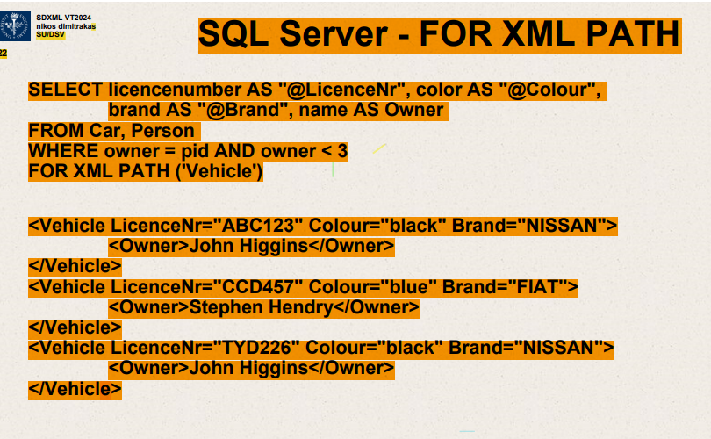

**SQL Query**:

* The SQL query selects three columns: licencenumber, brand, and name from the tables Car and Person.
* It aliases these columns for XML output as @LicenceNr, @Colour, and Owner.
* The query has a condition WHERE owner = pid AND owner < 3, which presumably filters the results based on the owner's ID being less than 3.
* The FOR XML PATH('Vehicle') part of the query specifies that the results should be formatted as XML, with each row wrapped in a <Vehicle> element.

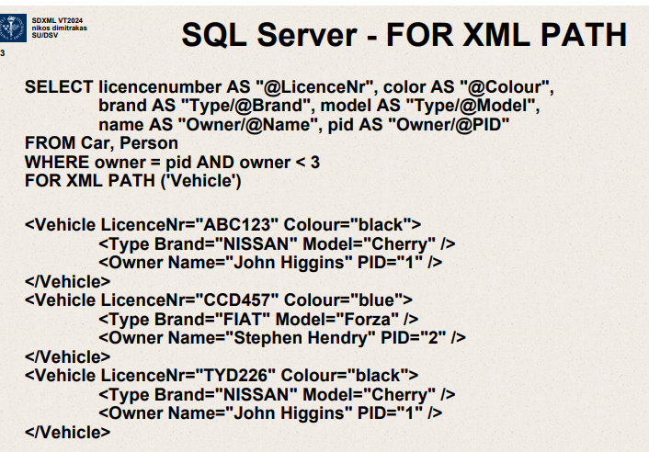

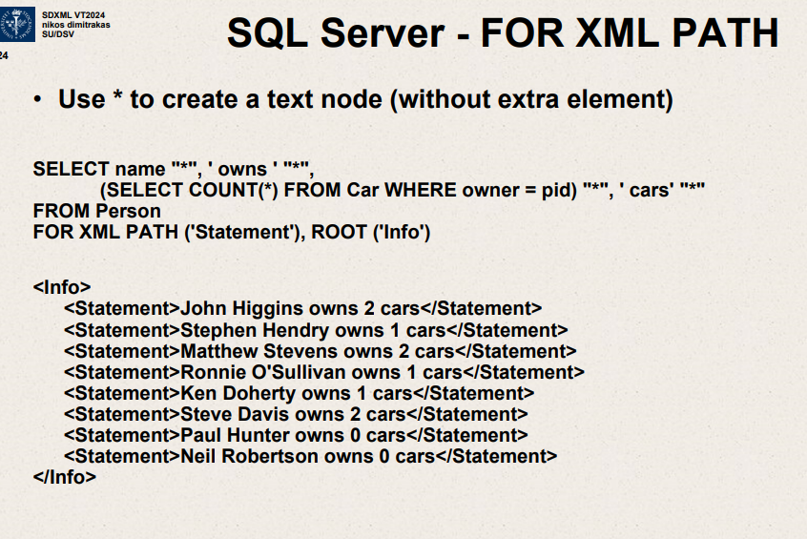

Use * to create a text node (without extra element)

The image you uploaded explains another use of the FOR XML PATH clause in SQL Server, focusing on creating a concatenated text node directly in the XML output without using additional XML elements for each column. Here’s what it demonstrates:

1. **SQL Query**:
   * The query combines text along with values from the database to format a string directly in the SQL query.
   * SELECT name + ' owns ' + (SELECT COUNT(*) FROM Car WHERE owner = pid) + ' cars' constructs a statement for each person, indicating how many cars they own.
   * The inner SELECT COUNT(*) FROM Car WHERE owner = pid counts how many cars each person owns. This value is concatenated with the person's name and the string "owns" to form a complete sentence.
2. **XML Output Structure**:
   * FOR XML PATH('Statement'), ROOT('Info') formats the output within <Statement> tags for each row, and all the <Statement> elements are nested within an <Info> root element.
   * This method is used to generate a straightforward list of statements about each person and the number of cars they own, encapsulated in XML format.
3. **Example Output**:
   * The output XML lists each person with a statement like "John Higgins owns 2 cars", "Stephen Hendry owns 1 cars", etc., where each statement is wrapped in a <Statement> element under the root element <Info>.

This technique is particularly useful when the desired output is a simple, readable format without the need for complex XML structures, suitable for situations where the XML is used for reports or simple data exchanges where readability is key.

SELECT name “*” , ‘ owns ‘ “*”,

(SELECT COUNT(*) FROM Car WHERE owner=pid ) “*” ,’cars’ “*”

FROM Person

FOR XML PATH(“Statement”) ,ROOT(‘Info’)

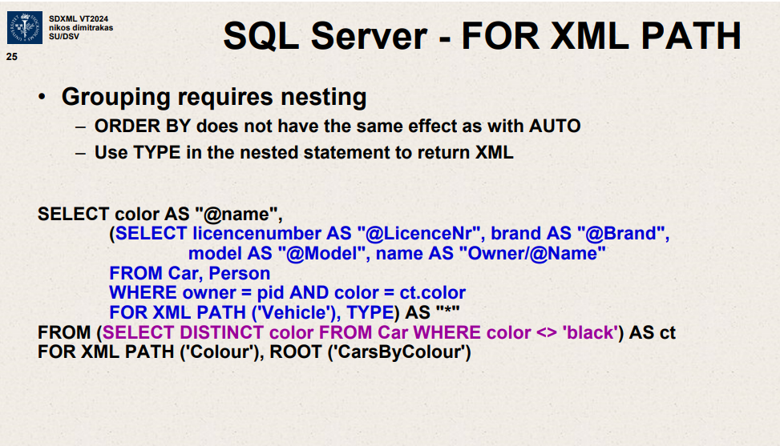

SELECT color AS “@name” ,

(SELECT licensenumber AS “@LicenseNr”,brand AS “@Brand” ,model AS “@Model” ,name AS “Owner/@Name”

FROM Car,Person

Where owner=pid AND color=ct.color

FOR XML PATH(‘Vehicle’),TYPE) AS “*”

FROM( SELECT DISTINCT color FROM Car WHERE color<> ‘black’)

FOR XML PATH(‘Colour’),ROOT (‘CarsByColour’)

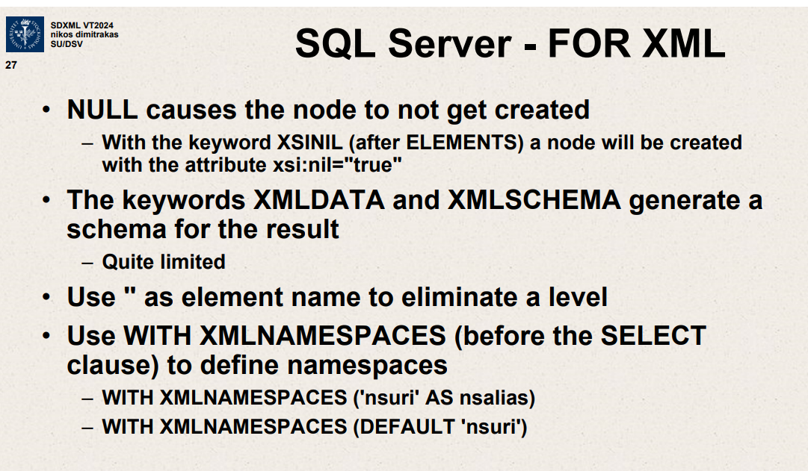

NULL causes the node to not get created.

With the keyword XSINIL (after ELEMENTS) a node will be created with attribute xsi:nil=”true”

The keywords XMLDATA and XMLSCHEMA generate a schema for the result.

Quite limited.

The slide you uploaded provides insights into some advanced features and functionalities available when using the FOR XML clause in SQL Server. Here’s a detailed explanation of the points mentioned:

**Handling NULL Values in XML**

* **NULL Behavior**: By default, if a column value is NULL, the XML node corresponding to that column will not be created in the output. This behavior ensures that the XML output is not cluttered with empty elements.
* **XSINIL Keyword**: If the XSINIL keyword is used (specifically after ELEMENTS), SQL Server will generate an XML node for the column even if its value is NULL. This node will include the attribute xsi:nil="true", indicating explicitly that the original value was NULL.

**XML Schema Generation**

* **XMLDATA and XMLSCHEMA**: These keywords are used to generate an XML schema for the XML output. XMLDATA was used in earlier versions of SQL Server and is quite limited. XMLSCHEMA provides a more robust method for generating a schema, but it is noted to have limitations as well, such as being less flexible than manually creating an XML schema.

**Simplifying XML Structure**

* **Using an Empty String as Element Name**: If you use an empty string "" as the element name in the FOR XML clause, SQL Server eliminates that level in the XML hierarchy, effectively flattening the structure. This can be useful to reduce the depth of the XML document.

**Defining XML Namespaces**

* **WITH XMLNAMESPACES**: This is used to define namespaces that are used within the XML document. Namespaces are crucial when the XML needs to be integrated with other systems that use the same tags but in different contexts, preventing collisions and clarifying scope.
  + **Specifying a Namespace**: WITH XMLNAMESPACES ('namespaceURI' AS prefix) declares a namespace URI and assigns a prefix to it, which can be used in the XML tags.
  + **Setting Default Namespace**: WITH XMLNAMESPACES (DEFAULT 'namespaceURI') sets the default namespace for elements in the XML document where no prefix is specified.

**Example Usage in a Query**

This slide does not show a full example SQL query using these features, but you could expect to see these options incorporated into a FOR XML query to control the structure and schema of the output, ensuring that the generated XML meets the needs of downstream applications or services, including adhering to specific standards for data exchange or integration.

Overall, these functionalities enhance the flexibility and capability of SQL Server when it comes to generating XML directly from SQL queries, allowing developers to tailor the output precisely for various applications.

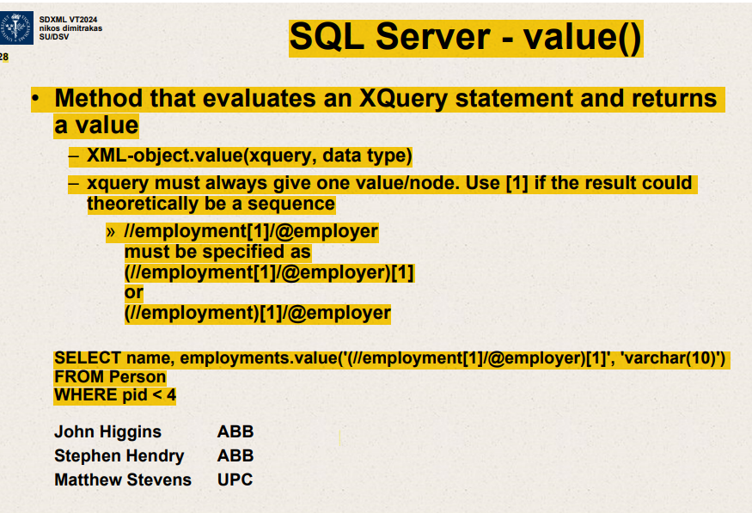

Slide explains the usage of the value() method in SQL server specifically

when working with XML data types.

.value() method used to extract values from XML data by applying Xquery to the XML column.

value() - method that evaluates an Xquery statement and returns a value.

XML-object.value(xquery,data type)

xquery must always give one value/node. Use [1] if result could theoretically be a sequence.

This slide explains the usage of the .value() method in SQL Server, specifically when working with XML data types. Here are the main points:

1. **Function Purpose**: The .value() method is used to extract values from XML data by applying an XQuery to the XML column.
2. **Syntax**:
   * XML-object.value(xquery, data type)
   * The xquery parameter specifies the query used to extract a value from the XML object.
   * The data type parameter specifies the type to which the result should be cast.
3. **XQuery Constraints**:
   * The XQuery must return exactly one value or node. If there is a possibility that the query might return multiple nodes or none, you must specify [1] to ensure only one result is considered.
   * Examples provided illustrate how to properly specify the path to ensure a single result:
     + (/employment[1]/@employer)[1]
     + /employment[1]/@employer
4. **SQL Query Example**:
   * The slide provides an example SQL query that selects names from a Person table where the person ID (pid) is less than 4, and extracts the employer from an employments XML column:

sql

Copy code

SELECT name, employments.value('(/employment[1]/@employer)[1]', 'varchar(10)')

FROM Person

WHERE pid < 4

* + This query extracts the first employer from each person's employment data and casts it as a varchar(10) string.

1. **Example Output**:
   * The example output shows names alongside their respective employers, demonstrating the result of applying the .value() method with the given XQuery and data type. For instance:
     + John Higgins is associated with ABB.
     + Stephen Hendry is also associated with ABB.
     + Matthew Stevens is associated with UPC.

This functionality is particularly useful for handling and extracting specific data from structured XML formats stored in SQL databases, allowing for efficient data retrieval and manipulation based on defined XML paths and attributes.

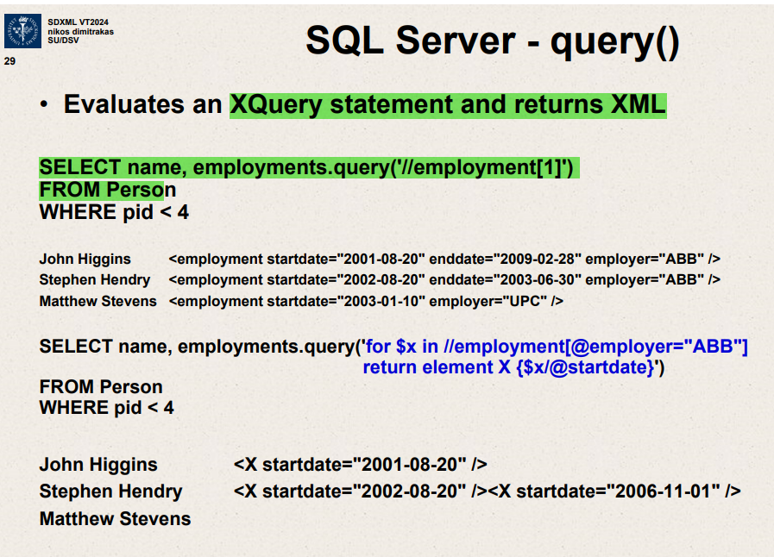

This slide explains the usage of the .query() method in SQL Server when working with XML data types. Here are the main points and examples provided:

1. **Function Purpose**:
   * The .query() method evaluates an XQuery statement against XML data in SQL Server and returns the resulting XML fragment.
   * Unlike the .value() method which extracts a value and converts it to a SQL data type, .query() returns XML data.
2. **First SQL Query Example**:
   * **SQL Statement**:

SELECT name, employments.query('/employment[1]')

FROM Person

WHERE pid < 4

* + **Description**: This query selects the name from the Person table where the person ID (pid) is less than 4 and extracts the first <employment> element from each person's employments XML data.
  + **Output**:
    - The results show the first <employment> element for each person, including attributes like startdate, enddate, and employer.

1. **Second SQL Query Example**:
   * **SQL Statement**:

sql

Copy code

SELECT name, employments.query('for $x in /employment[@employer="ABB"] return element X {$x/@startdate}')

FROM Person

WHERE pid < 4

* + **Description**: This query performs a more complex operation:
    - It uses an XQuery FLWOR statement (for, let, where, order by, return) to iterate over employment elements.
    - The query filters <employment> elements where the employer attribute is "ABB".
    - It constructs a new XML element <X> for each matching <employment>, containing only the startdate attribute.
  + **Output**:
    - The results show a new XML element <X> for each person, containing only the startdate attribute of their employment where the employer is "ABB".

This slide demonstrates the flexibility of using XQuery with SQL Server's XML data type to not only filter and extract information but also to transform XML data within SQL queries. This is particularly useful for applications where data needs to be dynamically processed and returned in different structured formats.

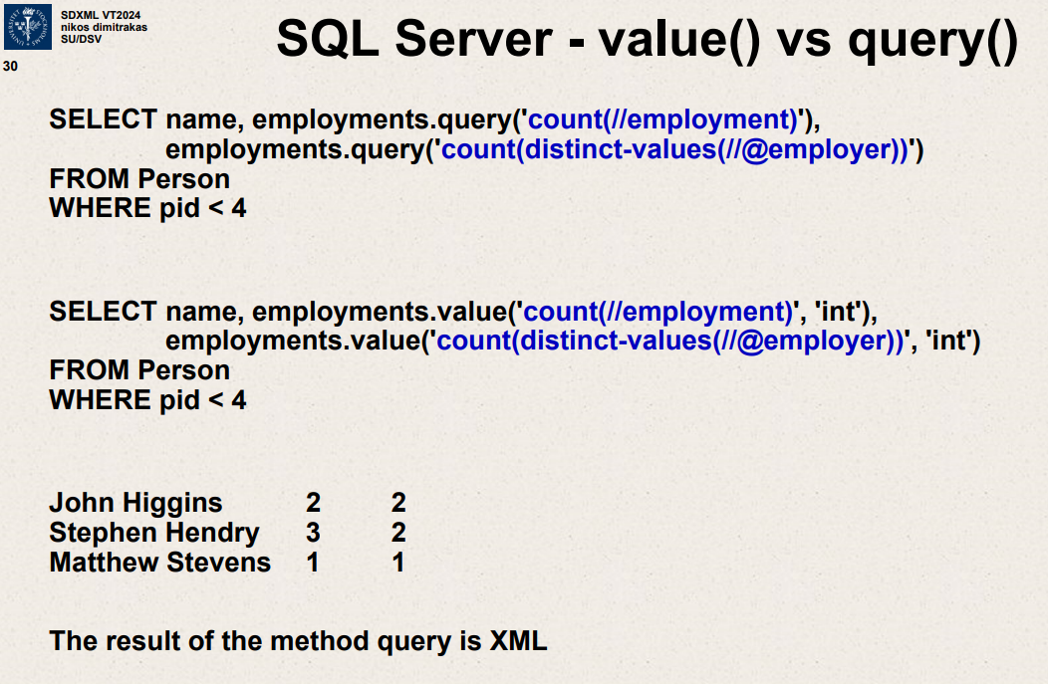

This slide contrasts the use of the .query() and .value() methods in SQL Server for XML data manipulation, using them in a practical example to demonstrate the difference in output and use cases:

1. **SQL Queries Using .query()**:
   * **SQL Statement**:

SELECT name, employments.query('count(//employment)'),

employments.query('count(distinct-values(/@employer))')

FROM Person

WHERE pid < 4

* + **Description**: This query uses the .query() method twice to perform two different calculations on the XML data in the employments column:
    - Count the total number of <employment> nodes.
    - Count the distinct values of the employer attribute across all <employment> nodes.
  + **Output Characteristics**: The output from .query() is XML, meaning the count results are encapsulated in XML format.

1. **SQL Queries Using .value()**:
   * **SQL Statement**:
   * SELECT name, employments.value('count(/employment)', 'int'),

employments.value('count(distinct-values(/@employer))', 'int')

FROM Person

WHERE pid < 4

* + **Description**: This query uses the .value() method similarly to perform the same calculations but converts the results directly to integers (int):
    - Count the total number of <employment> nodes.
    - Count the distinct employer attributes.
  + **Output Characteristics**: The results are returned as integer values, which makes them directly usable in SQL without further extraction or parsing.

1. **Output Comparison**:
   * **Example Results**:
     + John Higgins has 2 employment records with 2 distinct employers.
     + Stephen Hendry has 3 employment records with 2 distinct employers.
     + Matthew Stevens has 1 employment record with 1 distinct employer.
   * **Method Differences**: The output demonstrates how .value() is used to get direct scalar values from XML content, while .query() is used to retrieve structured XML data. .value() is generally more useful for numerical calculations or when you need to use the XML data as a scalar value in SQL operations.

This slide provides a clear example of choosing between .query() and .value() depending on whether the user needs XML structure preserved (.query()) or requires direct numerical output (.value()) for further SQL processing. This distinction is crucial in database operations where XML handling is frequent, enabling precise and efficient data retrieval and manipulation.

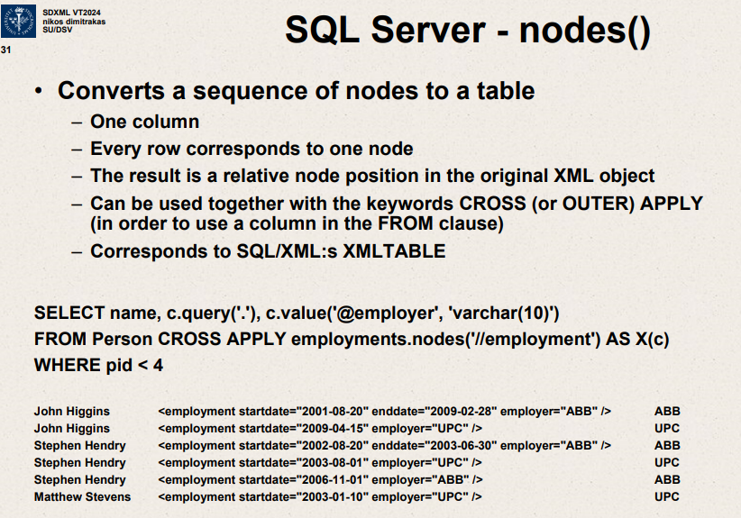

nodes() method in SQL server – explains its significance

converts a sequence of nodes to a table.

One column

Every row corresponds to one node

Result is a relative node position in the original XML object

Can be used together with keywords CROSS (or OUTER) APPLY ( in order to

use a column in FROM clause)

Corresponds to SQL/XML’s XMLTABLE

This slide introduces the .nodes() method in SQL Server, explaining its functionality and demonstrating how it can be utilized to manipulate XML data within SQL queries. Here's a breakdown of the slide's content:

1. **Function Purpose**:
   * **Converts a Sequence of Nodes to a Table**: The .nodes() method transforms a sequence of XML nodes into a relational table format. Each row in the resulting table corresponds to one node from the XML data.
2. **Usage**:
   * **One Column per Node**: The resulting table will have a column for each node.
   * **Row Correspondence**: Each row in the table corresponds to one node from the XML sequence.
   * **Relative Node Position**: The position of the node in the original XML object is retained in the relational output.
   * **Integration with SQL Queries**: The method can be used with the CROSS APPLY or OUTER APPLY keywords to join XML data to other table data in SQL queries.
   * **SQL/XML Compatibility**: This method is similar to the XMLTABLE feature in SQL/XML, which also allows XML data to be queried as if it were relational table data.
3. **Example SQL Query**:
   * **SQL Statement**:

SELECT name, c.query('.'), c.value('@employer', 'varchar(10)')

FROM Person

CROSS APPLY employments.nodes('//employment') AS X(c)

WHERE pid < 4

* + **Description**:
    - The query selects the name from the Person table and applies CROSS APPLY to expand the employments XML data into individual rows for each <employment> node.
    - It uses .nodes() to extract each <employment> node, represented by c in the FROM clause.
    - c.query('.') returns the XML content of the node.
    - c.value('@employer', 'varchar(10)') extracts the employer attribute from each node and casts it as a varchar(10).

1. **Output**:
   * The output of the example query shows each person’s name along with their employment details and employer, where each <employment> node creates a new row in the result set. This is particularly useful for extracting data from multiple nodes under a single XML column and for further relational operations.

This slide effectively illustrates how .nodes() can be used to bridge XML data handling with relational SQL operations, enhancing data extraction and manipulation capabilities in SQL Server.

SELECT name,c.query(‘.’),c.value(‘@employer’, ‘varchar(10)’)

FROM Person CROSS APPLY employments.nodes(‘//employment’) AS X(c)

WHERE pid<4

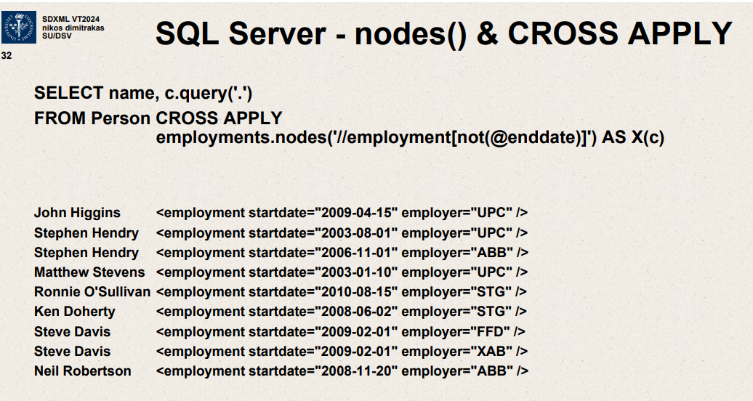

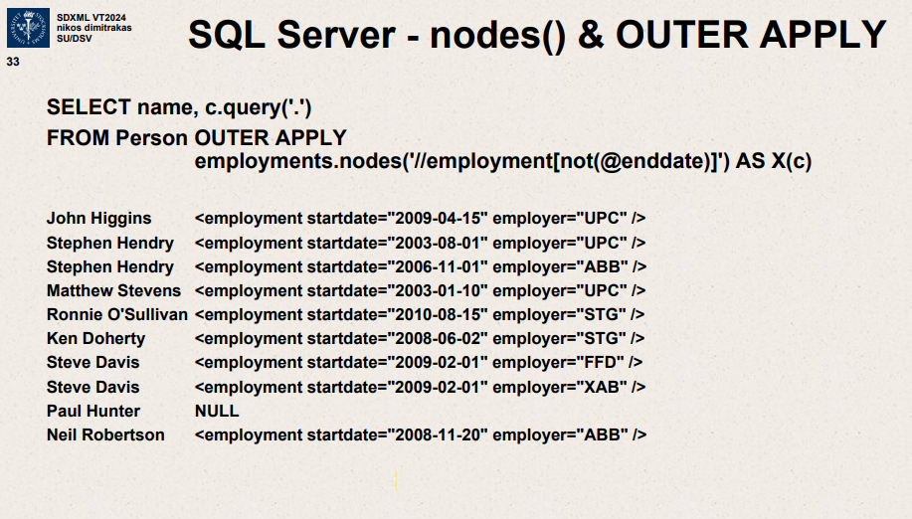

Includes even Paul Hunter though he has no employments which don’t have a

Enddate so it is null over there.

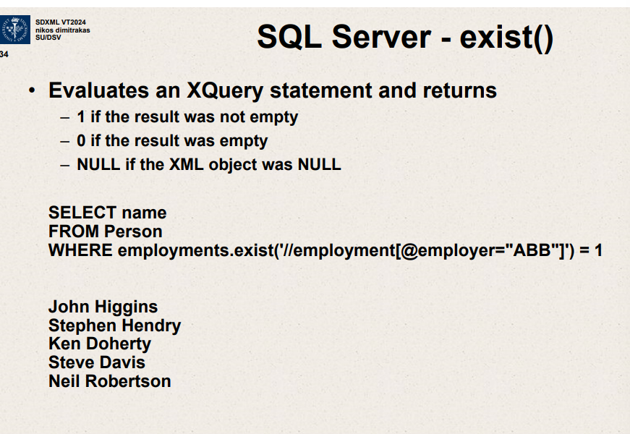

Evaluates an Xquery statement and returns

1 if result not empty

0 if empty

NULL if XML object NULL

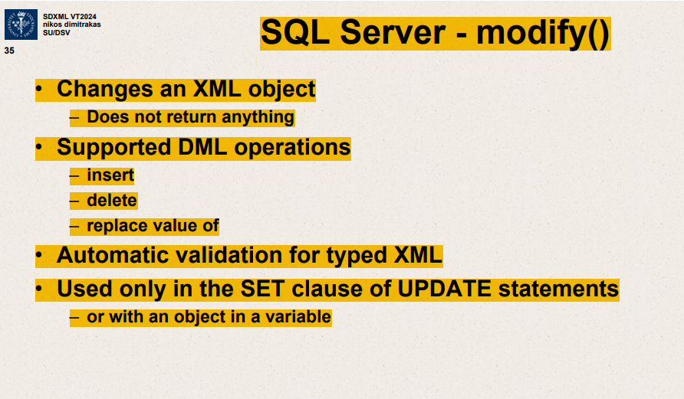

Changes an XML object

* Does not return anything

Supported DML operations

Insert

Delete

Replace value of

Automatic validation for typed XML

Used only in SET clause of UPDATE statements

This slide outlines the functionality of the .modify() method in SQL Server, specifically how it interacts with XML data types. Here’s a detailed explanation of the points mentioned:

1. **Functionality of .modify()**:
   * **Changes an XML Object**: The primary purpose of the .modify() method is to make modifications to XML data stored in a column or variable. It is designed to alter the XML in place.
   * **Does Not Return Anything**: Unlike other methods such as .query() or .value(), .modify() does not produce a return value. Its sole purpose is to update the XML content.
2. **Supported DML Operations**:
   * **Insert**: Adds new XML elements or attributes to the existing XML structure.
   * **Delete**: Removes elements or attributes from the XML.
   * **Replace Value Of**: Changes the value of an existing element or attribute within the XML.
   * These operations allow comprehensive manipulation of XML data, covering most needs for modifying XML content within a database.
3. **Automatic Validation for Typed XML**:
   * When the XML column is typed, meaning it conforms to a specified XML schema, the .modify() method automatically ensures that any changes adhere to the schema, preserving data integrity and compliance.
4. **Usage Context**:
   * **Used Only in the SET Clause of UPDATE Statements**: The .modify() method is specifically used within the SET clause of UPDATE SQL statements, making it integral to updating XML data in existing database records.
   * **Or with an Object in a Variable**: It can also be used to modify XML data held in SQL variables, allowing for dynamic XML data manipulation within SQL scripts.

**Example Usage:**

Here’s an example to illustrate how .modify() might be used in an SQL statement:

sql

Copy code

UPDATE Person

SET employments.modify('delete /employment[@id="123"]')

WHERE id = 1;

In this example:

* The employments XML column of the Person table is being modified.
* The .modify() method is used to delete an employment node where the attribute id equals "123".
* This operation is performed only for the person whose id is 1.

This slide is crucial for understanding how to directly manipulate XML data within SQL Server, enabling database administrators and developers to maintain and update their XML data efficiently and according to business needs or data changes.

explain this slide

ChatGPT

This slide outlines the functionality of the .modify() method in SQL Server, specifically how it interacts with XML data types. Here’s a detailed explanation of the points mentioned:

1. **Functionality of .modify()**:
   * **Changes an XML Object**: The primary purpose of the .modify() method is to make modifications to XML data stored in a column or variable. It is designed to alter the XML in place.
   * **Does Not Return Anything**: Unlike other methods such as .query() or .value(), .modify() does not produce a return value. Its sole purpose is to update the XML content.
2. **Supported DML Operations**:
   * **Insert**: Adds new XML elements or attributes to the existing XML structure.
   * **Delete**: Removes elements or attributes from the XML.
   * **Replace Value Of**: Changes the value of an existing element or attribute within the XML.
   * These operations allow comprehensive manipulation of XML data, covering most needs for modifying XML content within a database.
3. **Automatic Validation for Typed XML**:
   * When the XML column is typed, meaning it conforms to a specified XML schema, the .modify() method automatically ensures that any changes adhere to the schema, preserving data integrity and compliance.
4. **Usage Context**:
   * **Used Only in the SET Clause of UPDATE Statements**: The .modify() method is specifically used within the SET clause of UPDATE SQL statements, making it integral to updating XML data in existing database records.
   * **Or with an Object in a Variable**: It can also be used to modify XML data held in SQL variables, allowing for dynamic XML data manipulation within SQL scripts.

The .modify() method is specifically used within the SET clause of UPDATE SQL statements, making it integral to updating XML data in existing database records.

UPDATE Person

SET employments.modify('delete /employment[@id="123"]')

WHERE id = 1;

When the XML column is typed, meaning it conforms to a specified XML schema, the .modify() method automatically ensures that any changes adhere to the schema, preserving data integrity and compliance.

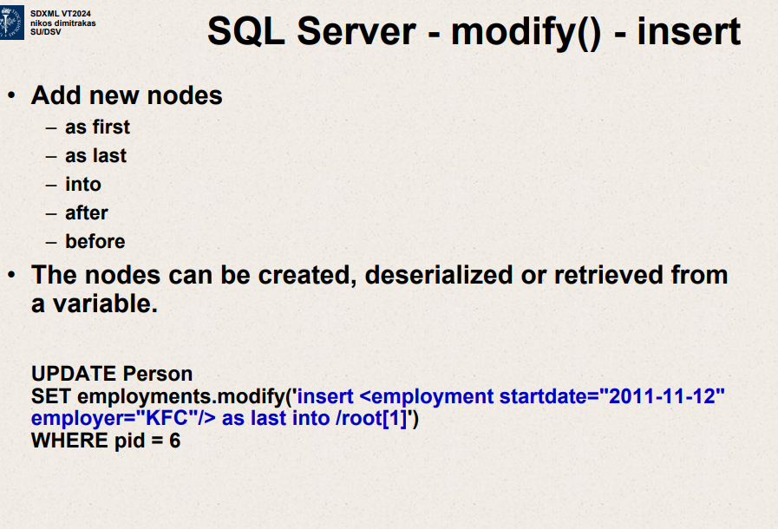

modify() – insert

add new nodes

as first

as last

into

after

before

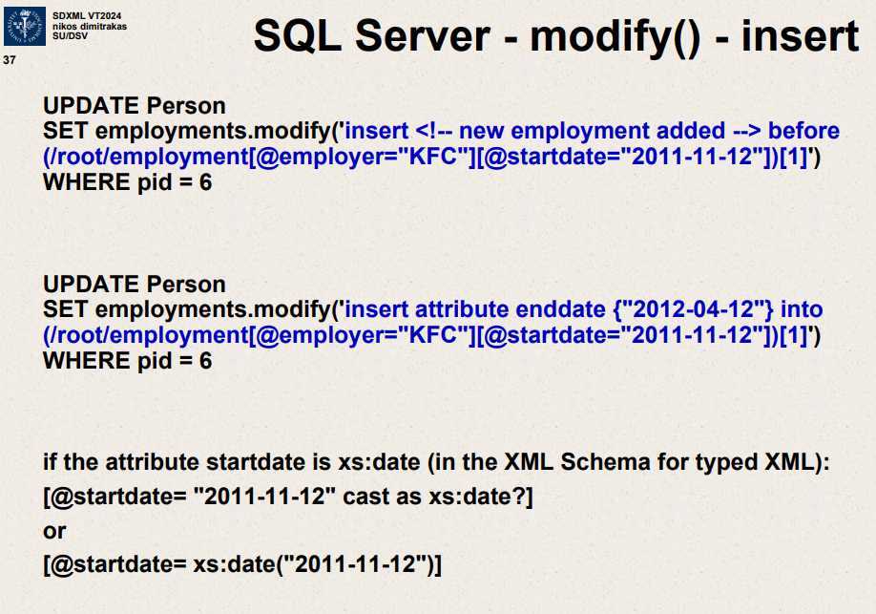

The slide you're referring to covers the use of the .modify() method in SQL Server for inserting content and attributes into XML data within a database. It presents two distinct SQL UPDATE examples that manipulate an XML column based on specific criteria. Here's a detailed explanation of each query:

**First Query: Inserting a Comment**

UPDATE Person

SET employments.modify('insert <!-- new employment added --> before (/root/employment[@employer="KFC"][@startdate="2011-11-12"])[1]')

WHERE pid = 6

* **Purpose**: This command is used to insert a comment within the XML data in the employments column of the Person table.
* **Operation**:
  + **Insert Comment**: <!-- new employment added --> is a comment indicating a new employment record has been added. Comments in XML are like annotations and do not affect the data.
  + **Location**: The comment is inserted before the first <employment> element that matches the specified criteria (employer="KFC" and startdate="2011-11-12").
* **Target**: The specific <employment> node within the <root> element that matches both the employer and startdate attributes is targeted.
* **Where Clause**: This operation is applied only to the row where pid (Person ID) equals 6.

**Second Query: Inserting an Attribute**

sql

Copy code

UPDATE Person

SET employments.modify('insert attribute enddate {"2012-04-12"} into (/root/employment[@employer="KFC"][@startdate="2011-11-12"])[1]')

WHERE pid = 6

* **Purpose**: This command adds a new attribute to an existing XML node within the employments column.
* **Operation**:
  + **Insert Attribute**: The attribute enddate with the value "2012-04-12" is added.
  + **Location**: The attribute is added to the first <employment> element matching the employer "KFC" and the startdate "2011-11-12".
* **Target**: The specific <employment> node within the <root> element is targeted again based on the employer and startdate.
* **Where Clause**: As before, this modification is restricted to the row where pid equals 6.

**Explanation on Typed XML and Date Handling**

The slide also discusses handling attributes as typed data (in this case, dates), showing how you might ensure the XML data conforms to types specified in an XML Schema:

* **Typed XML**: If your XML schema defines the startdate attribute as a date type (xs:date), you can cast or check the attribute using xs:date in your queries. This ensures that the data conforms to expected types, improving data integrity and compatibility with XML standards.

**Overall Understanding**

These examples illustrate advanced XML manipulation techniques using SQL Server, allowing for dynamic updates directly within the XML data stored in database columns. This capability is particularly useful for maintaining complex data structures within a single database column and ensures that XML data can be programmatically modified to reflect changes in data or application state.

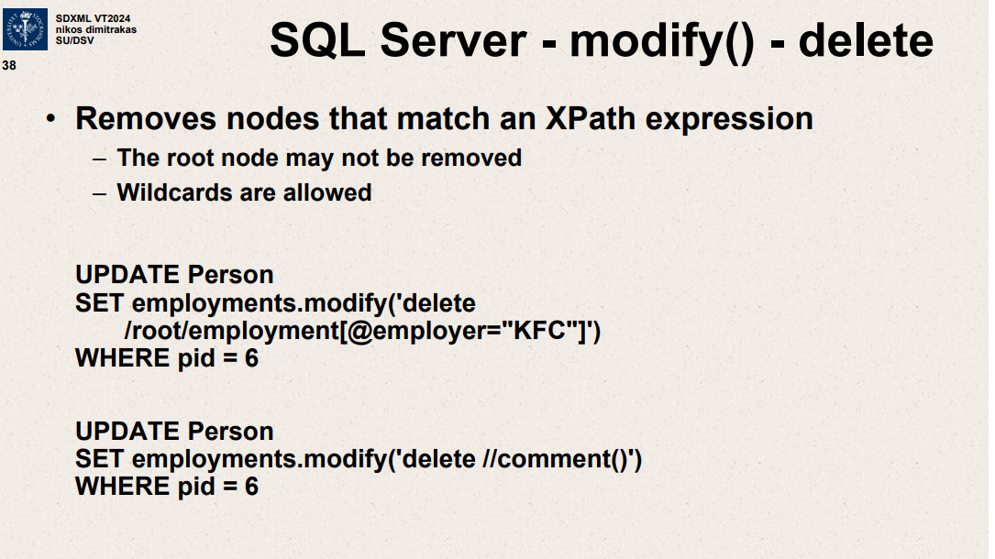Top of Form

Removes nodes that match an Xpath expression

Root node may not be removed.

Wildcards are allowed.

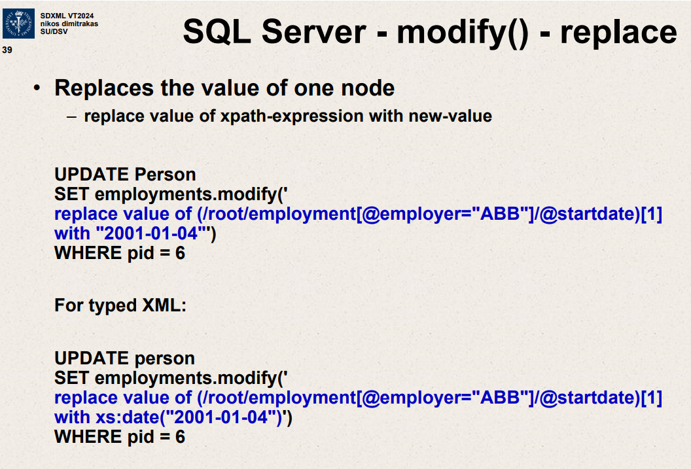

This slide explains how to use the .modify() method with the replace value of operation in SQL Server to update the value of a node within an XML column. The slide gives two examples, one for regular XML and another for typed XML. Let's break down each example:

**Example 1: Regular XML**

UPDATE Person

SET employments.modify('replace value of (root/employment[@employer="ABB"]/@startdate)[1] with "2001-01-04"')

WHERE pid = 6

* **Purpose**: This command is used to replace the startdate attribute of the first <employment> element where the employer attribute is "ABB".
* **Operation**:
  + **XPath**: (root/employment[@employer="ABB"]/@startdate)[1] identifies the first startdate attribute within <employment> nodes under the <root> that have an employer attribute equal to "ABB".
  + **Replacement**: Replaces the current value of the startdate attribute with "2001-01-04".
* **Target**: This modification affects only the XML data within the employments column of the Person table for the person with pid = 6.

**Example 2: Typed XML**

sql

Copy code

UPDATE person

SET employments.modify('replace value of (root/employment[@employer="ABB"]/@startdate)[1] with xs:date("2001-01-04")')

WHERE pid = 6

* **Purpose**: Similar to the first example, but this command specifies the data type of the new value using XML Schema (XS) data types.
* **Operation**:
  + **XPath**: Identical to the first example, targeting the first startdate attribute within <employment> nodes where employer equals "ABB".
  + **Replacement with Type**: Here, the value "2001-01-04" is explicitly cast as an xs:date. This ensures that the new value conforms to the XML Schema definition for dates, which is important for data integrity and validation in typed XML columns.
* **Target**: Affects the employments XML data for the person with pid = 6.

**General Explanation**

These queries showcase the flexibility of SQL Server's XML data manipulation capabilities, particularly:

* **replace value of**: This is a specific operation within the .modify() method that directly updates the content of an XML node or attribute.
* **Typed vs. Untyped XML**: The second example demonstrates the additional step required when dealing with XML that conforms to a schema (typed XML), ensuring that all modifications adhere to the specified types in the schema, thus avoiding data type errors and maintaining consistency.

Both examples illustrate essential techniques for maintaining and updating complex data structures stored in XML format within relational databases, catering to scenarios where data integrity and compliance with predefined schemas are crucial.

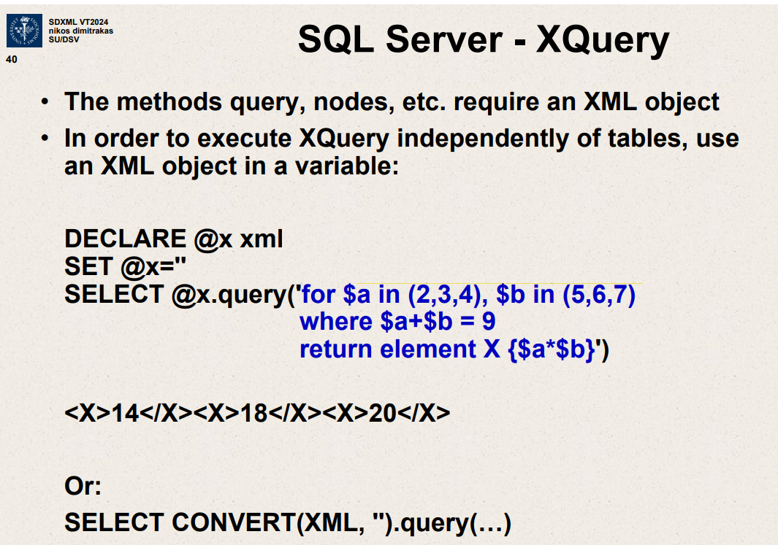

This slide discusses how to utilize XQuery within SQL Server to execute queries against XML data stored in variables, independent of a database table.

The slide provides a practical example illustrating how to declare an XML variable and use XQuery to perform calculations and construct XML elements based on the results. Let’s break it down:

**Key Concepts Introduced:**

1. **XQuery**: A query and functional programming language, used primarily for querying and transforming XML data.
2. **XML Object in Variable**: Storing XML directly in a variable allows for manipulating XML data without needing to interact with database tables directly.

**Example Breakdown:**

**Declaration and Initialization:**

DECLARE @x xml

SET @x='' -- Assuming the XML content would be set here

* **DECLARE @x xml**: This line declares a variable named @x of the XML data type.
* **SET @x=''**: This line would typically initialize @x with XML content. In the slide, it appears empty but it's meant to show where the XML data would be assigned.

**XQuery Execution:**

sql

Copy code

SELECT @x.query('

for $a in (2,3,4), $b in (5,6,7)

where $a+$b = 9

return element X {$a*$b}

')

* **XQuery Expression**: This SQL Server uses XQuery to query the XML data stored in the variable:
  + **for $a in (2,3,4), $b in (5,6,7)**: Iterates over two sets of numbers. $a takes values from 2 to 4, and $b takes values from 5 to 7.
  + **where $a+$b = 9**: Filters combinations of $a and $b where their sum equals 9.
  + \**return element X {$a*$b}**: For each pair that satisfies the condition, it returns an XML element <X> with the content set to the product of $a and $b.

**Example Output:**

xml

Copy code

<X>14</X><X>18</X><X>20</X>

* **Output**: The result is a sequence of <X> elements containing the products of the pairs (2,7), (3,6), and (4,5) because these pairs sum to 9 and their products are 14, 18, and 20 respectively.

**Alternative with CONVERT:**

sql

Copy code

SELECT CONVERT(XML, '').query(...)

* **Purpose**: This line hints at an alternative method of directly converting a string to XML and running an XQuery on it, though it’s not detailed in the slide.

**Summary:**

The slide effectively demonstrates how to use XQuery within SQL Server to manipulate and query XML data held in variables, highlighting the language's ability to perform complex queries and return structured data. This technique is particularly useful for scenarios where XML data needs to be processed or analyzed without storing it in a table, or where the XML is generated dynamically within SQL scripts.

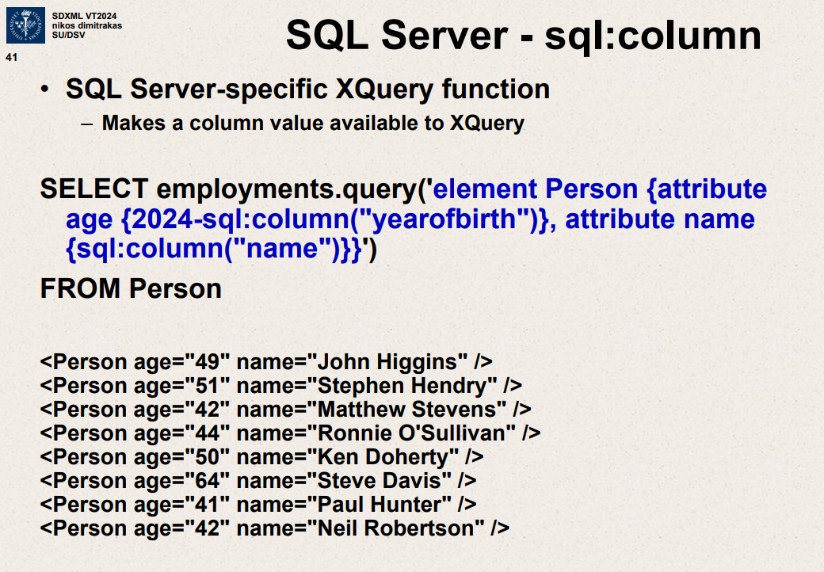

The slide you've shared provides an example of using SQL Server's sql:column function within an XQuery expression to dynamically include column values from a database in the output XML.

The sql:column function helps in integrating data from SQL columns directly into XML results, a common requirement in scenarios where SQL data needs to be rendered in XML format for web services or data interchange.

The SQL command on the slide:

sql

Copy code

SELECT employments.query('element Person {attribute age {2024-sql:column("yearofbirth")}, attribute name {sql:column("name")}}')

FROM Person

This SQL command is supposed to generate XML elements for each person, with attributes for age and name dynamically pulled from the SQL columns yearofbirth and name. The 2024-sql:column seems to be a typo or a placeholder, typically it should just be sql:column.

The output below the command is showing XML data for various persons with their ages and names as attributes, which represents how the data would appear when the query is executed, given a correctly structured database and the proper use of sql:column.

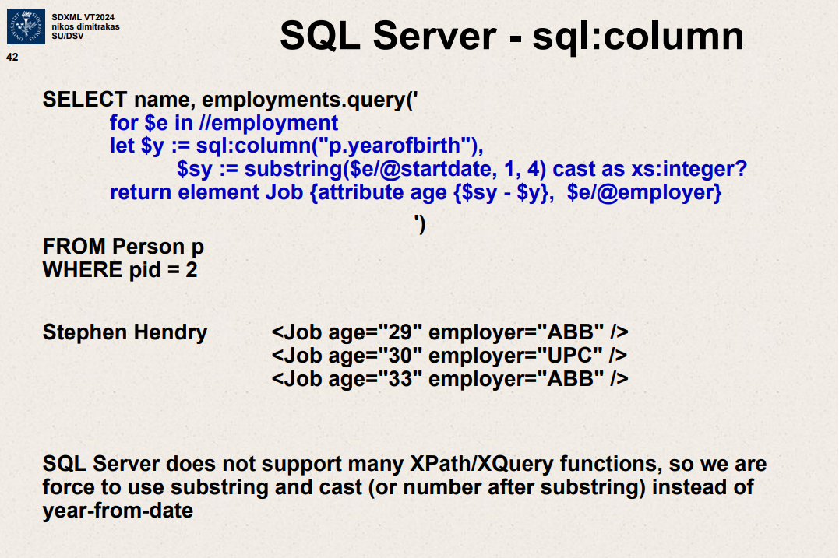

The slide you provided illustrates another example of using SQL Server's XQuery capabilities, specifically utilizing the sql:column function within an XML query to dynamically pull data from SQL columns and use it in XML results. Here's a breakdown of the query and its components:

**SQL Query Explanation**

1. **Query Definition:**

SELECT name, employments.query('...XQuery...')

FROM Person p

WHERE pid = 2

This SQL query selects the name of a person and performs an XQuery on the employments field (presumably an XML-type column) for a specific person identified by pid = 2.

1. **XQuery Part:**

for $e in //employment

let $y := sql:column("p.yearofbirth"),

$yy := substring($e/@startdate, 1, 4) cast as xs:integer?

return element Job {attribute age {$yy - $y}, $e/@employer}

* + for $e in //employment: This iterates over all <employment> elements in the employments XML column.
  + let $y := sql:column("p.yearofbirth"): Declares a variable $y and assigns it the value from the SQL column yearofbirth of the table Person aliased as p.
  + $yy := substring($e/@startdate, 1, 4) cast as xs:integer?: Extracts the year part from the startdate attribute of each <employment> element and converts it to an integer. This value is stored in variable $yy.
  + return element Job {attribute age {$yy - $y}, $e/@employer}: Constructs a new <Job> element for each <employment>. It includes an age attribute calculated by subtracting $y from $yy, and copies the employer attribute from the original <employment> element.

1. **Output:**

xml

Copy code

<Job age="29" employer="ABB" />

<Job age="30" employer="UPC" />

<Job age="33" employer="ABB" />

These are the resulting <Job> elements showing the computed age and employer for each employment record of the person Stephen Hendry.

**Notes on SQL Server and XML Handling**

* **XPath/XQuery Limitations in SQL Server:** SQL Server's implementation of XML handling does not support a wide range of XPath/XQuery functions. As a workaround, operations like extracting the year from a date are done using SQL functions (like substring) and then casting the result to an integer.
* **Practical Use Case:** This kind of query is useful in transforming relational data into a structured XML format, which can be particularly beneficial for applications needing XML output, like interfacing with web services or generating reports in XML format.

This SQL and XQuery integration demonstrates the power and flexibility of SQL Server in handling complex data transformation scenarios directly within the database engine.

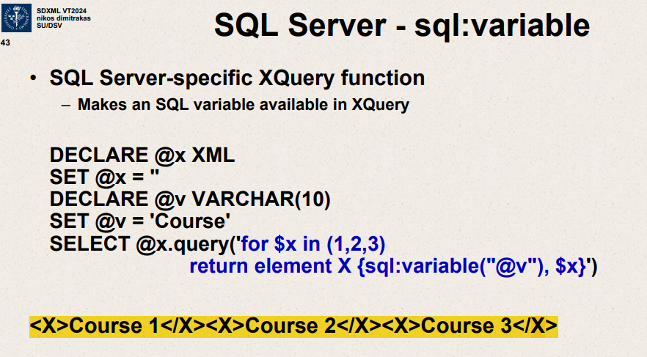

SQL Server specific Xquery function

This slide explains how to use an SQL Server-specific XQuery function, sql:variable, which allows you to make an SQL variable available within an XQuery. Here’s a detailed breakdown of the slide:

**SQL Server - sql**

* **Purpose**: The slide shows how to use the sql:variable function in SQL Server to include SQL variables in XQuery expressions.

**Example Code Explanation:**

1. **DECLARE @x XML**:
   * This line declares a variable @x of type XML.
2. **SET @x = ''**:
   * This initializes the @x variable with an empty XML string.
3. **DECLARE @v VARCHAR(10)**:
   * This line declares a variable @v of type VARCHAR with a maximum length of 10 characters.
4. **SET @v = 'Course'**:
   * This sets the value of the @v variable to the string 'Course'.
5. **SELECT @x.query(...)**:
   * This line uses the .query method on the XML variable @x to execute an XQuery.
   * **XQuery Details**:

sql

Copy code

for $x in (1,2,3)

return element X {sql:variable("@v"), $x}

* + - for $x in (1,2,3): This part of the XQuery loops over the sequence (1, 2, 3).
    - return element X {sql:variable("@v"), $x}: For each item in the sequence, it creates an XML element <X> containing the concatenation of the value of @v (which is 'Course') and the current value of $x.

**Output:**

The output of the query will be:

xml

Copy code

<X>Course 1</X><X>Course 2</X><X>Course 3</X>

This shows that the XQuery has generated XML elements for each number in the sequence, prefixed by the value of the SQL variable @v.

**Summary:**

* The slide demonstrates how to integrate SQL variables into XQuery using the sql:variable function.
* It shows a practical example where an SQL variable (@v) is combined with a sequence of numbers to produce XML elements dynamically.

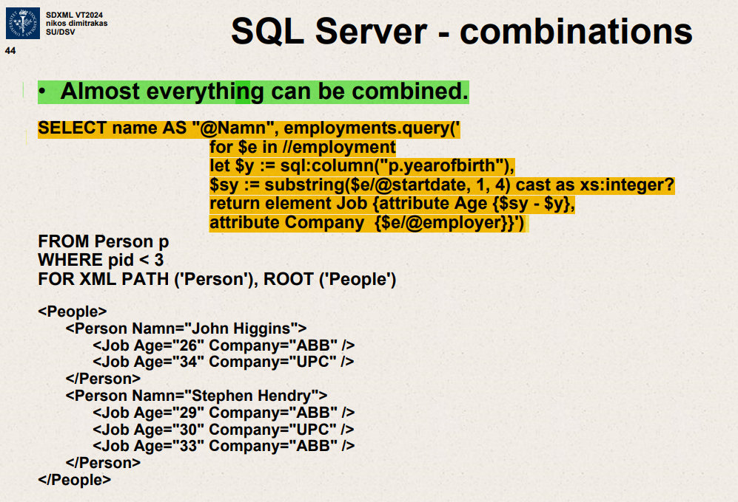

This slide explains how to combine SQL queries and XQuery in SQL Server to generate XML output. The example provided demonstrates how to create a complex XML structure by combining data from SQL columns and XML elements.

**Key Concepts:**

* **Combining SQL and XQuery**: The slide shows how to use XQuery to process XML data within SQL Server queries, demonstrating the power of combining these technologies.

**Example Code Explanation:**

1. **SELECT Clause**:
   * **name AS "@Namn"**: Selects the name column and renames it to @Namn in the XML output.
   * **employments.query(...)**: Executes an XQuery on the employments column.
2. **XQuery Details**:

for $e in //employment

let $y := sql:column("p.yearofbirth"),

$sy := substring($e/@startdate, 1, 4) cast as xs:integer?

return element Job {

attribute Age {$sy - $y},

attribute Company {$e/@employer}

}

* + for $e in //employment: Iterates over each <employment> element.
  + let $y := sql:column("p.yearofbirth"): Assigns the value of the SQL column yearofbirth to the variable $y.
  + $sy := substring($e/@startdate, 1, 4) cast as xs:integer?: Extracts the year from the startdate attribute of the <employment> element and casts it to an integer.
  + return element Job { ... }: Returns a new <Job> element for each <employment> element.
    - attribute Age {$sy - $y}: Calculates the age by subtracting yearofbirth from the start year.
    - attribute Company {$e/@employer}: Includes the employer attribute from the <employment> element.

1. **FROM Clause**:
   * **FROM Person p**: Specifies the source table Person with alias p.
   * **WHERE pid < 3**: Filters the rows where pid is less than 3.
2. **FOR XML PATH and ROOT Clauses**:
   * **FOR XML PATH ('Person'), ROOT ('People')**: Specifies the XML structure.
     + PATH ('Person'): Each row from the query results will be wrapped in a <Person> element.
     + ROOT ('People'): The entire result set will be wrapped in a root <People> element.

**Output Explanation:**

The generated XML structure will look like this:

xml

Copy code

<People>

<Person Namn="John Higgins">

<Job Age="26" Company="ABB" />

<Job Age="34" Company="UPC" />

</Person>

<Person Namn="Stephen Hendry">

<Job Age="29" Company="ABB" />

<Job Age="30" Company="UPC" />

<Job Age="33" Company="ABB" />

</Person>

</People>

* **<Person Namn="John Higgins">**: A <Person> element for John Higgins.
  + <Job Age="26" Company="ABB" />: A <Job> element with age and company attributes for each employment.
* **<Person Namn="Stephen Hendry">**: A <Person> element for Stephen Hendry.
  + Multiple <Job> elements with different ages and companies, calculated based on the employment data.

**Summary:**

* The slide demonstrates how to create a nested XML structure by combining SQL data with XQuery.
* The example shows the use of SQL variables within XQuery to dynamically generate XML elements and attributes.
* The output XML reflects the structure defined in the FOR XML PATH and ROOT clauses, with nested elements for each person and their corresponding jobs.